Choose PRINT or SAVE AS.. under your browser's FILE menu if you wish to read this article later.

Please hit the BACK button on your browser to return to website.

Article published in Business Executive Magazine 1995
CONSULTING  WITH THE FLOW  Change Management Consulting For Real  By Tony Coyle and Tony Page  Part 1:  Letting Go  The article is published in two parts. Part 2 is entitled “The Vision Thing”. | 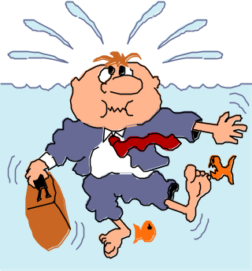    

In this article the writers contrast their own experience of Change Management with the theory.

They discover the limits of their current Change Management mind-set.

They develop a new paradigm for Change Management that is related to the new relationship between employee and corporation.

They begin to set out a hypothesis or guiding metaphor called Flow Theory for use by change agents.

They invite others interested in Change Management to enter the debate.

Tony Coyle is Director, Organisation Development at SmithKline Beecham Pharmaceuticals, Europe.

Tony Page is a partner in Page Consulting, a practice that helps people in organisations understand, engage with and work through change issues.

How it all started
Imagine the scene. It is the summer of 1994, you are 18 months into a working partnership on a change programme with a major corporation. Your offices are filled with hundreds of books and manuals describing how to manage change. There are Total Quality Management (TQM) manuals, Customer Service manuals, Business Process Re-engineering (BPR) manuals, the Transformational Leadership approach, the “very well-known Board-level strategic consultancy” Change Management product, the “biggest world-wide IT consultancy” Change Management product... and so on.



You have also in previous years researched the subject of Change Management from all imaginable angles, developed education for others and consulted to line managers in many different corporate settings.

So when you meet your colleague later in the summer with a challenging brief to develop a “world class” Change Management product you are well-equipped. You could cull the best from the pile of manuals, combine it with your own live consulting experience and (hey presto!) you would have a Change Management product that is distinctive, tangible, holistic, results-based and widely applicable within your client company.

We had faced worse mountains. However, when we tried to get started, something began causing us a problem. We had two or three separate meetings spaced over a couple of months. Our approach kept shifting. There was an uncomfortable feeling. Question: What was the source of this feeling? Answer: A mismatch between the theory of Change Management and our real life experience.

Experiencing change
What real life experience are we talking about? As Change Agents we all work at the centre of change, in the eye of a storm, and we experience change directly. The words people use to describe this kind of experience cover the full spectrum of human experience both negative and positive including:

shock, terror, rush, uncontrollable anger, sinking, exhaustion, despair, wild euphoria, excitement, surges of confidence, inspiration, insight, new-found purpose.

Such emotional experiences are equally true for all people in the midst of change: production workers, middle managers, planners, top executives, customers and change agents. In other words they apply to all the human stakeholders engaged in a change process.

Emotions arise in a well-known and (partially) predictable cycle that goes something like this:

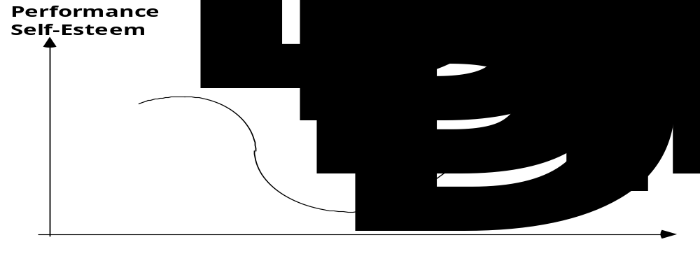

But, in business as we all know, emotional experience is largely hidden, not referred to and tends to be seen as weakness.

Two opposing theories: hard vs soft
If you were to delve into the pile of books and manuals in our offices you would probably not find out much more about the emotional colour of change but you might remark on how much is written on Change Management and how incomplete each offering is. Here are some themes we identified:

• the human experience of change (soft) inhabits a separate professional domain from the strategic (hard) and both are partially blind towards the other

• in the "hard" school (strategy, structure, systems, performance, BPR, consultancy, operations) the human side of change is typically Machiavellian, about ends not means, maintaining power, management by fear, command and control, seeing the lowest in human nature, theory X, anti-empowerment and the nature of resistance is misconceived

• in the "soft" school (people, psychology, counselling, employee assistance, therapy) the human issues in change are illuminated but detached from a business setting

• a fusion between "hard" and "soft" was glimpsed in the “culture” movement of the 80s and in TQM but with the rise of BPR the old divisions re-emerge

• BPR is becoming more widely recognised as flawed, the human element in change is seen as being the missing link

• Change Management has emerged as a new fusion between the hard and the soft schools, the carrier of the human element

• the “hard” school with its roots in strategy, performance and BPR serves the top level decision-makers in business and is still dominant in the emerging field of Change Management. Approaches to Change Management are in many cases confused and inadequate in their conception of the human element at work.

We felt that until the two schools are better integrated there is not and cannot be an effective, results-based connection between people and business.

Let us turn to how the Change Agent experiences change.

Experiencing change: the Change Agent’s view
As a Change Agent you experience directly the battle between the two schools. For example you can be engaged by the "hard" school to discover the hidden merits of the other "soft" school. This is a difficult role to fulfil.

In a recent London seminar, a corporate transformation "guru" claimed that of the thousands of change programmes initiated in corporations throughout the world there are probably only five (amongst them British Airways) that have produced truly outstanding results. Why?

Leaving aside the reasons and the evidence for this assertion, where does it leave you as a Change Agent? Marooned, high and dry, faced with untenable options. Which option do you choose:
1. Continue to blindly follow the old and discredited theory of change management
2. Transfer your faith to the revised theory being promoted
3. Develop something pragmatic “at the grass roots” avoiding potentially flawed theory altogether?
The answer seemed to us to be in a fourth option: attempt to reconnect theory with our own lived experience.

We therefore begin by proposing a simple Kolb-style “learning approach” to Change Management that integrates theory and experience by drawing the best from existing theory, using it and testing it, reflecting on experience and evolving the theory forward to embrace your operating experience and to guide future action. In this way we all get better at being Change Agents as we move forward.

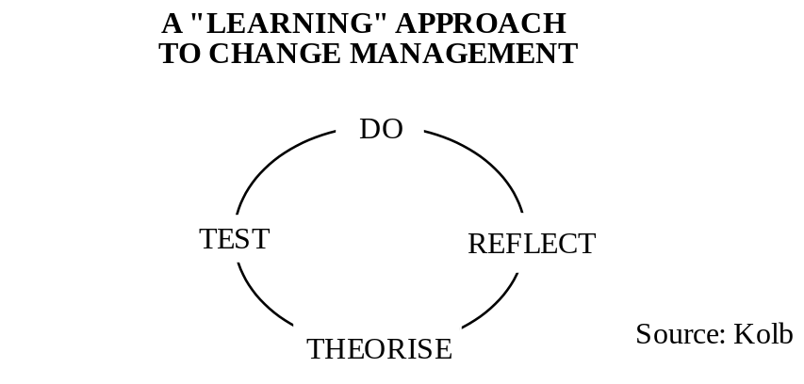

Behaviour patterns and assumptions
If only it were that simple! Have a look at this example of a Change Agent's experience:

"at the start of a change programme you personally invest hope, dedication and optimism, only to find some months or years afterwards that the programme is mired in stuckness, desperation, pessimism and failure.

On the way you typically have subjected yourself and your clients to a wide range of intense emotions in your drive to achieve a mutually beneficial result.

When the change programme is beginning to fail you recognise but are helpless to prevent the change energy moving on to the next “fad”. Within the new fad you see the client repeating essentially the same Change Management mistakes."

In summary here is the behaviour pattern:
• attraction to fad
• design of corporate change programme
• hope and dedication invested
• delusion of success
• recognition of failure
• rejection of old programme
• attraction to next fad
• repetition of cycle with only subtle and minor changes.

The example shows that, by examining your own subjective experience of change, truthfully and dispassionately, you can glimpse your underlying patterns of behaviour. These in turn could give clues to your assumptions about change management which guide your decisions and “cause” your current levels of success and failure as a Change Agent.

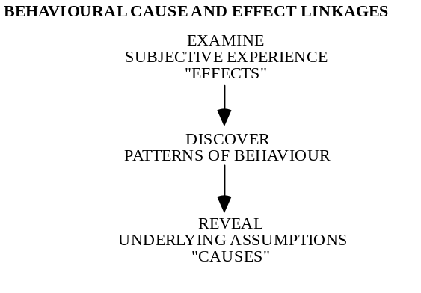

Change Agent heal thyself
“Doctor heal thyself” is a comment made by clients when they see Change Agents not taking their own advice. All of us have blindspots. The expert on human behaviour is no less likely to be arrogant or insensitive in their relationships than a window cleaner or a brain surgeon. Your blindspots as a Change Agent are very damaging to you both directly by undercutting the client's confidence in you and by adding to the general confusion during change.

Blindspots are behaviours we are unaware of but to others seem inappropriate or self-defeating. In the example the client’s repetition of failure as they move from one fad to the next can be a blindspot in the client. Coupled with it the Change Agent’s inability to leverage learning in the client can be a Change Agent blindspot.

Emotion is a major blindspot for Change Agents. We sometimes pretend that everything in business operates rationally and deny the absolute centrality of emotion, both our own and our clients'. The human cycle of change is well-known from studies of bereavement and from the world of counselling. In the wake of Tom Peters and others it is now widely accepted that in business the customer’s “perception is reality”. If this is true it must equally be true that a client’s perception of a change programme (not top management's or the change agent's intention) is the reality of that programme. Then why do we not explore the client's perception fully and place the human cycle of change centrally in all corporate change management programmes?

The problem of blindspots is compounded by the lack of integration in Change Management theory between the hard and soft schools. The effect of this is that everyone engaged in a change programme has their own version, is working off different assumptions (invisible to others) and suffering from different blindspots (invisible to them).

Uncloaking the change paradigm
As Change Agents our effectiveness depends on holding a set of assumptions about change, that is a "paradigm", that works effectively in our daily practice.

Goss, Pascale and Athos (see references) describe a paradigm as being "the colour of the light" which makes things appear the way they do. Change the colour of the light bulb in the room then furniture, fabrics and decorations that previously went well together begin to clash, previously prominent objects recede into the background, new objects become prominent.

A paradigm is implicit, invisible and not easy to discover. If we could articulate the particular mixture of assumptions (from both the hard and soft schools) that we are working to, then we would have revealed our paradigm, we could then, using a "learning approach", shed what is not working and over time evolve it into a more effective paradigm.

But how? A good starting point is to identify "uncomfortable feelings" and any "dissonance between feelings and behaviour". For example, growing in the writers for some time has been a dissatisfaction with conventional approaches to change management. A personal diary has been used to record and to explore "uncomfortable feelings", then a dialogue between the writers served to expose the behaviour patterns and assumptions which were underlying our practice. We have in effect been removing the invisible cloak to reveal our “change paradigm” in order to update it. This article records our journey.

Outdated assumptions
Here are some of the writers' implicit and outdated assumptions about how to manage change (causes) which produce various dysfunctional results (effects) that we have observed in our practice:

ASSUMPTION: Change must start at the top
The Board should work with a task force of consultants to define their corporate purpose, vision, values, strategy and change agenda. The troops should accept leadership from the generals. If the direction is right, the Board should win people's hearts and minds.

RESULT: Change is first experienced by others in the company as being pre-determined, imposed and distant from them.

ASSUMPTION: Rushing will help speed change up
The Board needed time for themselves to explore, debate and unite around change. But change is urgent. Now the Board should simply explain their decision. Other people should understand and follow.

RESULT: A programme is rushed and pushed out onto others. It is disconnected from other people’s internal emotional reality, it is a bolt-on to the real job not integrated. Early polarisation occurs into supporters and resisters, positions become entrenched. Rushing change slows progress and increases resistance.

ASSUMPTION: Top people must behave as role models
Individuals particularly top managers should demonstrate loyalty and support for the change. They should do this even if they are not sure themselves about the change.

RESULT: Role models lack conviction. The implicit message from role models is the company expects you to disconnect yourself from your true feelings. Hearts and minds are being lost not won. Motivation and energy are dissipated.

ASSUMPTION: Reward and reinforcement should be aligned
If a person supports change they should gain survival and reward. If they resist change they should experience disapproval and negative consequences.

RESULT: Experienced people pretend support and commitment when in reality they feel rushed, confused or opposed. Resistance is driven underground. Commitment is replaced with compliance. Learning is going on all the time but is not given a voice. A hidden, but more real life arises beneath the surface. Meetings become like the Woody Allen film where the speech and the feelings subtext are disconnected and in opposition.

ASSUMPTION: News will filter through if there is a problem
If a manager has an "open door policy" their finger should be on the pulse of the company and they should soon find out about any problems that exist.

RESULT: Top managers assume they are in touch but in a driven, forced change programme become progressively more detached from true feelings of staff. Resistance remains hidden. People act as if they are committed or open-minded but hide their feelings. Management decisions become progressively more inappropriate and disconnected from the motivations, needs and values of staff.

ASSUMPTION: Consultants and facilitators can be used to carry the message out
The top team needs expert support to take the message out, to preach to and convert the troops.

RESULT: Consultants and facilitators are no longer seen as objective or impartial but cynically as dishonest and manipulative, doing the Board’s dirty work. Experienced people learn how much to engage with facilitators/consultants and how much to keep hidden. Much of the hidden life remains hidden. The full potential of facilitation/consultancy expertise remains untapped. Facilitators/consultants and their clients become disappointed. The Board feels a loss of control. The change programme hits the rocks. Board members resign and are replaced. The cycle begins again. The company sails forward unchanged into oblivion.....

The emotional experience of letting go
In uncloaking our paradigm, emotions arise. There is some sense of confusion throughout and as the reality sinks in there is a mixture of mild embarrassment, anger, blame, guilt and anxiety.

The experience of this is not easy or intellectually detached. It is involved, private, challenging, unsettling. We found ourselves acknowledging that our old change paradigm was dishonest and divisive. It created barriers and disconnections within a corporation. It forced internal disconnection within individuals between feelings and behaviours thus eroding personal integrity, self-esteem and confidence. It nurtured cynicism as a coping mechanism. It fed resistance which operated mostly unintentionally and subconsciously. It damaged corporate performance both in the short term due to the fear, uncertainty and doubt it generates and in the medium to longer term through the destruction of trust, integrity and shared purpose in the business. It was counter-productive and illusory, a fool's paradise, promising a united approach via change into a desired future but delivering the opposite: a destruction, a division, an entrapment in the present. Pretty damning stuff!

The anger passes as you realise you are free, that the old cloak no longer fits you. It has become unpleasant to wear, you have shed it for ever. At this stage the emotions are mild anxiety, despair, neutrality, acceptance. You have let go of the old but you do not have anything yet to put in its place.

At the stage of our journey, we were still left wondering how could we have got it all so wrong? Did our old change paradigm ever work? What had changed to make it so ineffective now?

______________________
Part 2
The second and final part of this article is called "The Vision Thing" and is due to appear in the next edition.
______________________

Choose PRINT or SAVE AS.. under your browser's FILE menu if you wish to read this article later.

Please hit the BACK button on your browser to return to website.

